**Q19. Which of the following sets of quantum numbers are correct?**  
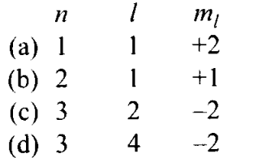

**Sol:** (b, c) If n = 1, l ≠ 1. Hence, (a) is wrong.  
If n = 2, l= 0, 1. For l = 1, m = -1, 0, +1. Hence (b) is correct.  
If n = 3, l= 0, 1,2. For l = 2, m = -2, -1, 0, +1, +2. Hence (c) is correct.  
If n = 3, l ≠4. Hence, (d) is wrong.